Ethan Daugherty

SNHU

CS-340-T4528

3-1 Milestone: Database Indexing and Authentication

03/06/2022

**Database Indexing and Authentication**

**Part I: Importing and Indexing a Data Set**

You have been asked to import a file for the Grazioso Salvare project. To do so, you must complete the following steps:

1. In Apporto, open the terminal window to access the Linux shell. Upload the Austin Animal Center (AAC) Outcomes data set into MongoDB by **importing a CSV file using the appropriate MongoDB import tool.** Use the database name “AAC” and collection name “animals”. Complete the import using the mongoimport tool and take screenshots of both the import command and its execution.

Tip: How to import a CSV file is covered in the mongoimport documentation in the Module Three Resources. The Austin Animal Center (AAC) Outcomes data set has already been uploaded into Apporto in the */usr/local/datasets/* directory. The filename is “aac_shelter_outcomes.csv”.

1. After importing your data set, start up the mongo shell. **Create a simple** index on the key “breed”. Show an example query that will use this index and verify that the index will be used with the **explain function. Take screenshots** of your example query.  
   Text

   Description automatically generatedText

   Description automatically generated  
   Text

   Description automatically generated Text

   Description automatically generated
2. **Create a compound index** that will improve the performance of queries looking for breeds that have an “outcome_type” of “Transfer”. Show an example query that will use this compound index and confirm the index will be used with the **explain function. Take screenshots** of your example query.  
   Text

   Description automatically generated  
   Text

   Description automatically generated

**Part II: User Authentication**

1. To comply with your client’s security needs, you have been asked to ensure user authentication to the database by setting up both administrator and user accounts. To achieve this, follow the steps below.

Create an administrator account in the mongo shell by following steps #2–3 of the MongoDB Manual Enable Access Control tutorial. Then exit the mongo shell.  
  
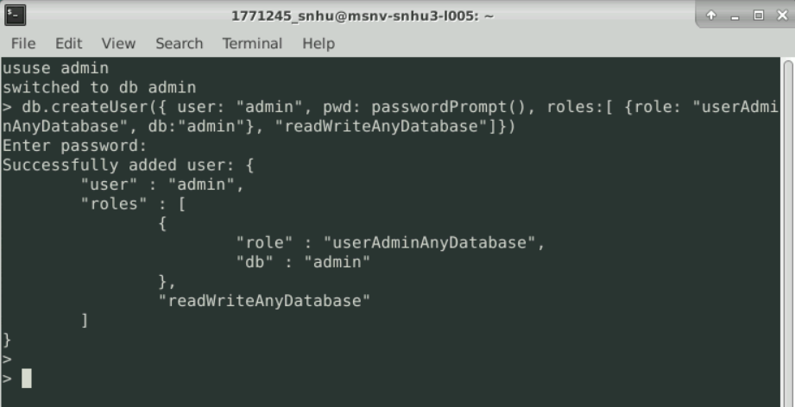

**IMPORTANT:** Write down the password for the admin account and keep it somewhere safe. You will need to use this account later in the course.

1. **Enable user authentication for the database** by typing the following commands exactly into the Linux shell in Apporto:

*/usr/local/bin/mongod_ctl stop*

*/usr/local/bin/mongod_ctl start  
*

You can verify that you have enabled user authentication by accessing MongoDB with your new username/password. Type the following command into the Linux shell to start mongo:

*mongo --authenticationDatabase "admin" -u "admin" -p*

This will prompt you to enter your password. Then use the command to show databases to verify that you have set up authentication correctly. If you are not logged in with your admin account, no databases will be viewable.

**Note:** These commands have been customized for the Apporto environment. If you are accessing MongoDB on your own machine, refer to the MongoDB Manual Enable Access Control tutorial.

If you accidentally messed up user authentication, or if you forgot your password, you can disable user authentication with this set of commands:

*/usr/local/bin/mongod_ctl stop*

*/usr/local/bin/mongod_ctl start-noauth*

1. **Create a new user account called “aacuser”** for the database AAC in the mongo shell. Refer to steps #6–7 of the MongoDB Manual Enable Access Control tutorial, linked above, to help you with this task. You will need to modify the commands so that the account name is “aacuser”.  
   Text

   Description automatically generated

**IMPORTANT:** Write down the password for the aacuser account and keep it somewhere safe. You will need to use this account later in the course.

1. **Take a screenshot** of your login process to MongoDB using the mongo shell. Be sure you can access MongoDB and list the databases using both the admin and aacuser accounts, as this will verify that your accounts are working. You should be able to include the login commands for both accounts in one screenshot, but if you can not, include two screenshots to show both login commands.  
   Graphical user interface, text

   Description automatically generated  
   Text

   Description automatically generated  
   Text

   Description automatically generated  
   Text

   Description automatically generated